Mexico, Scientific Experiments by the End of the World

It was supposed to be a very special day – December 21, 2012. One of the interpretations of Mayan calendar was announced to the world as an End of the World. Global flooding, earthquake or a comet – everyone was offered to create his/her own version. Scientists declined these ideas, but a lot of people were waiting for the day. Thousands of books were published, in many places “emergency packets” with candles and canned food were sold, and a lot of people were supposed to gather in Mexico for this day. So we decided to see what will happen using scientific instruments.
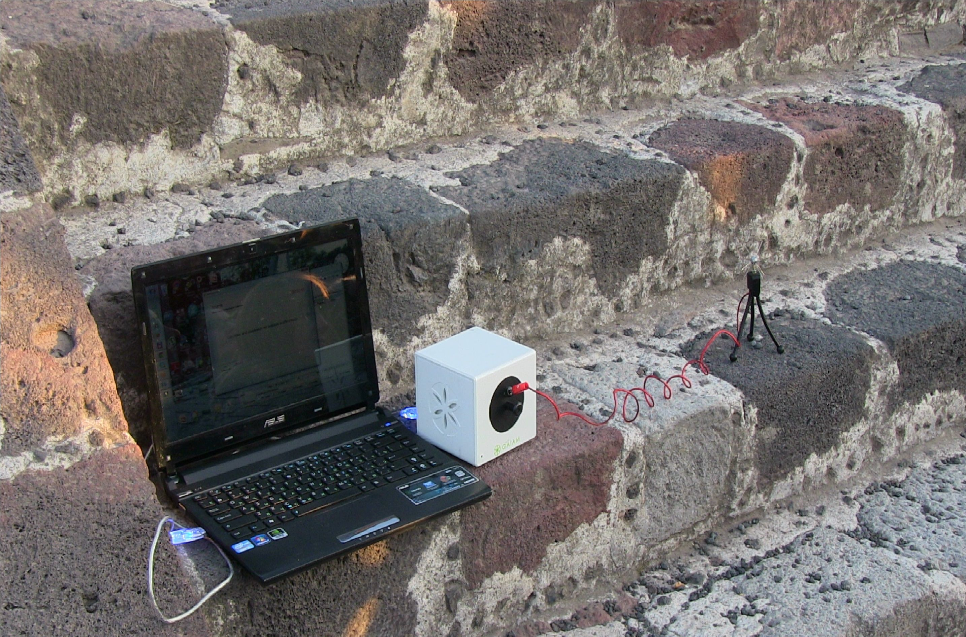
Fig.38. “Sputnik” sensor
We were using “Sputnik” sensor (fig.38) which allows to record time variations of atmosphere influenced both by the geo-physical situations, like storms and geo-magnetic turbulences, and by human emotions and intentions.
Teotihuacan pyramids
On December 19 at night I arrived to Teotihuacan in Mexico and next day we were busy with the workshop of Dr Ruiz. In the morning I turned Sputnik on at 9 am in the hotel situated about 2 km from the pyramids and let it run for the whole day. Processing the data I was surprised to see that energy was increasing for two hours and only then became stable (fig.39). Similar process was recorded December 21 (fig.40). During the day energy was quite stable in both days.
This effect is quite unusual and may signify that in both days some energy process took place in the atmosphere.

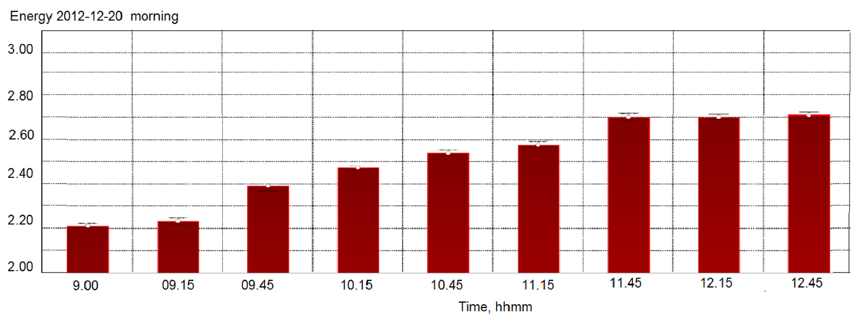
Fig.39. Time dynamics of Energy parameter in the morning December 20 in the hotel
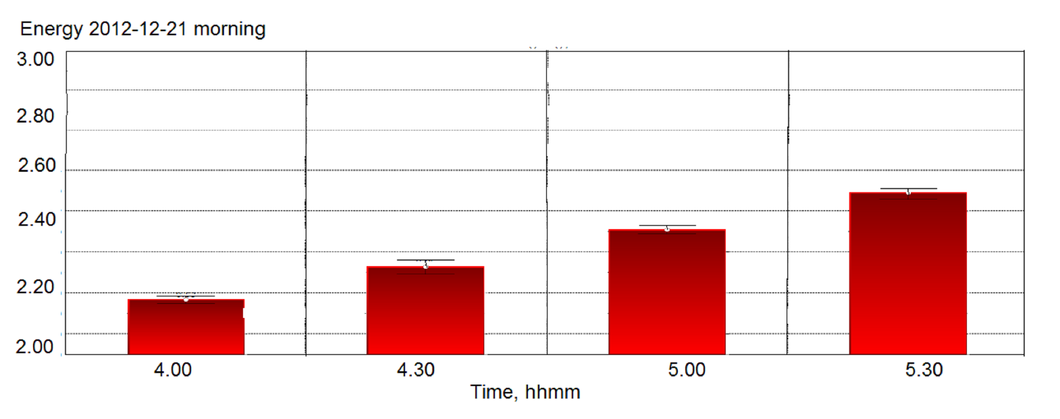
Fig.40. Time dynamics of Energy parameter in the morning December 21 in the hotel
In both days collective meditations at the Teotihuacan pyramids were conducted by Don Miguel Ruiz and his group of students. A special agreement allowed to make it when pyramid complex was closed for visitors. Sputnik sensor was position nearby the group and in both cases increase of energy was detected. Fig 4 demonstrates energy parameter detected in the process of meditation nearby the Moon pyramid and energy nearby the Sun pyramid. Please pay attention that in both cases energy is higher than in the hotel (fig.39-40) but the highest one was detected during collective meditation.

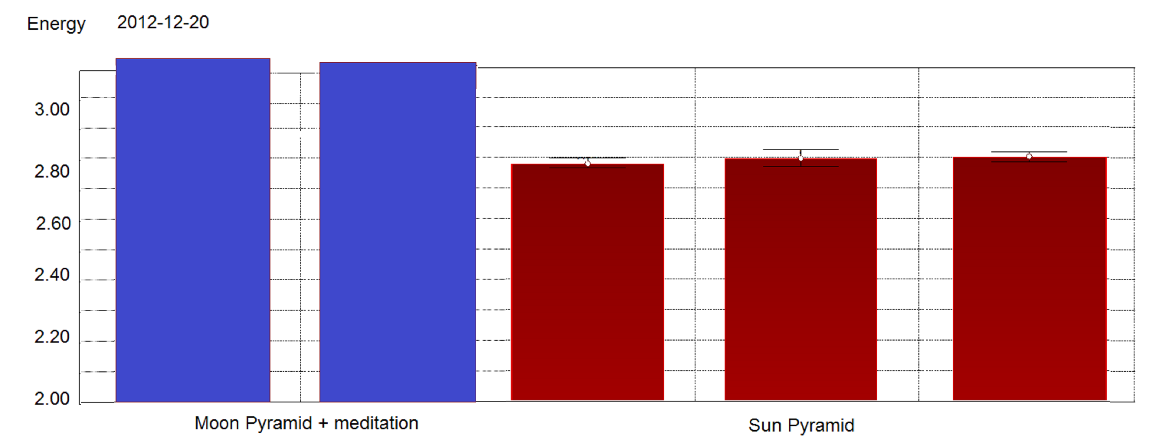
Fig.41. Energy parameters measured nearby Moon and Sun pyramids on December 20

Outstanding results were detected at the collective meditation on December 21 morning (fig.42).
We arrived to the Pyramids at 5 am, when complex was closed for visitors, but we had a special permission to enter. We were standing in total darkness looking to the stars with great pyramid at our back. We meditated – all 10 of us together – and the feeling of Universe penetrated deeper and deeper in our Souls. By the end Don Ruiz sent his intentions to the Sensor from the distance.
As we see from the graph fig,42, all these moments were reflected on the Sensor’ parameters time dynamics. Statistical processing of these data clearly demonstrated these effects (fig.43).

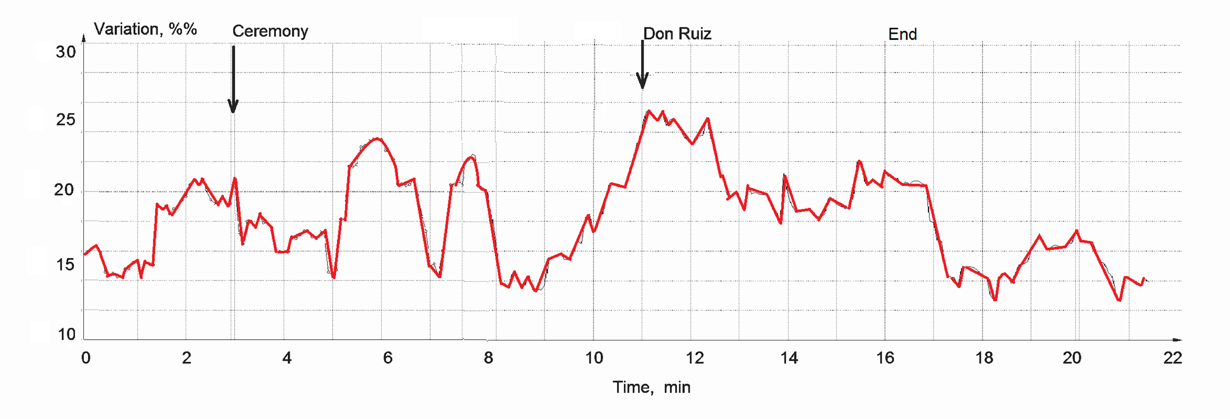
Fig.42. Time dynamics of Energy parameters measured during meditation nearby Sun pyramid in the morning December 21

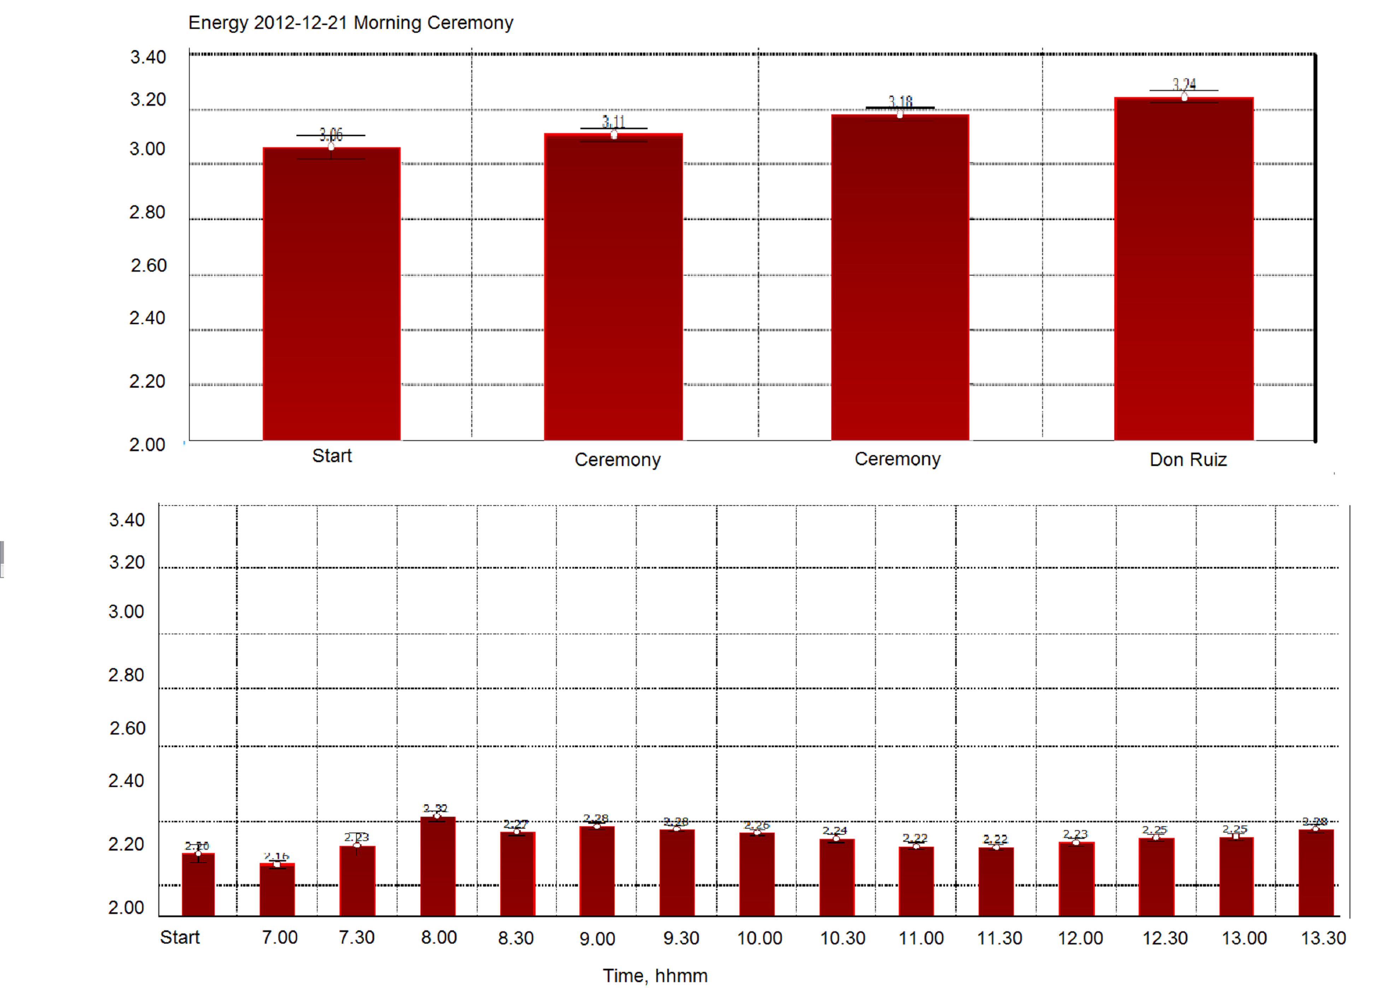
Fig.43. Energy parameters measured nearby Sun pyramid and in the hotel December 21

Again, the energy nearby pyramids was much higher than in the hotel and it had strong peaks during meditation. For the comparison at fig.43 the graphs of energy measured at the hotel during the day and nearby the pyramids are presented in the same scale.
Measurements at the top of Sun pyramid in the afternoon 21.12 demonstrated similar data to the ones presented at fig.40 – much higher than at the hotel.
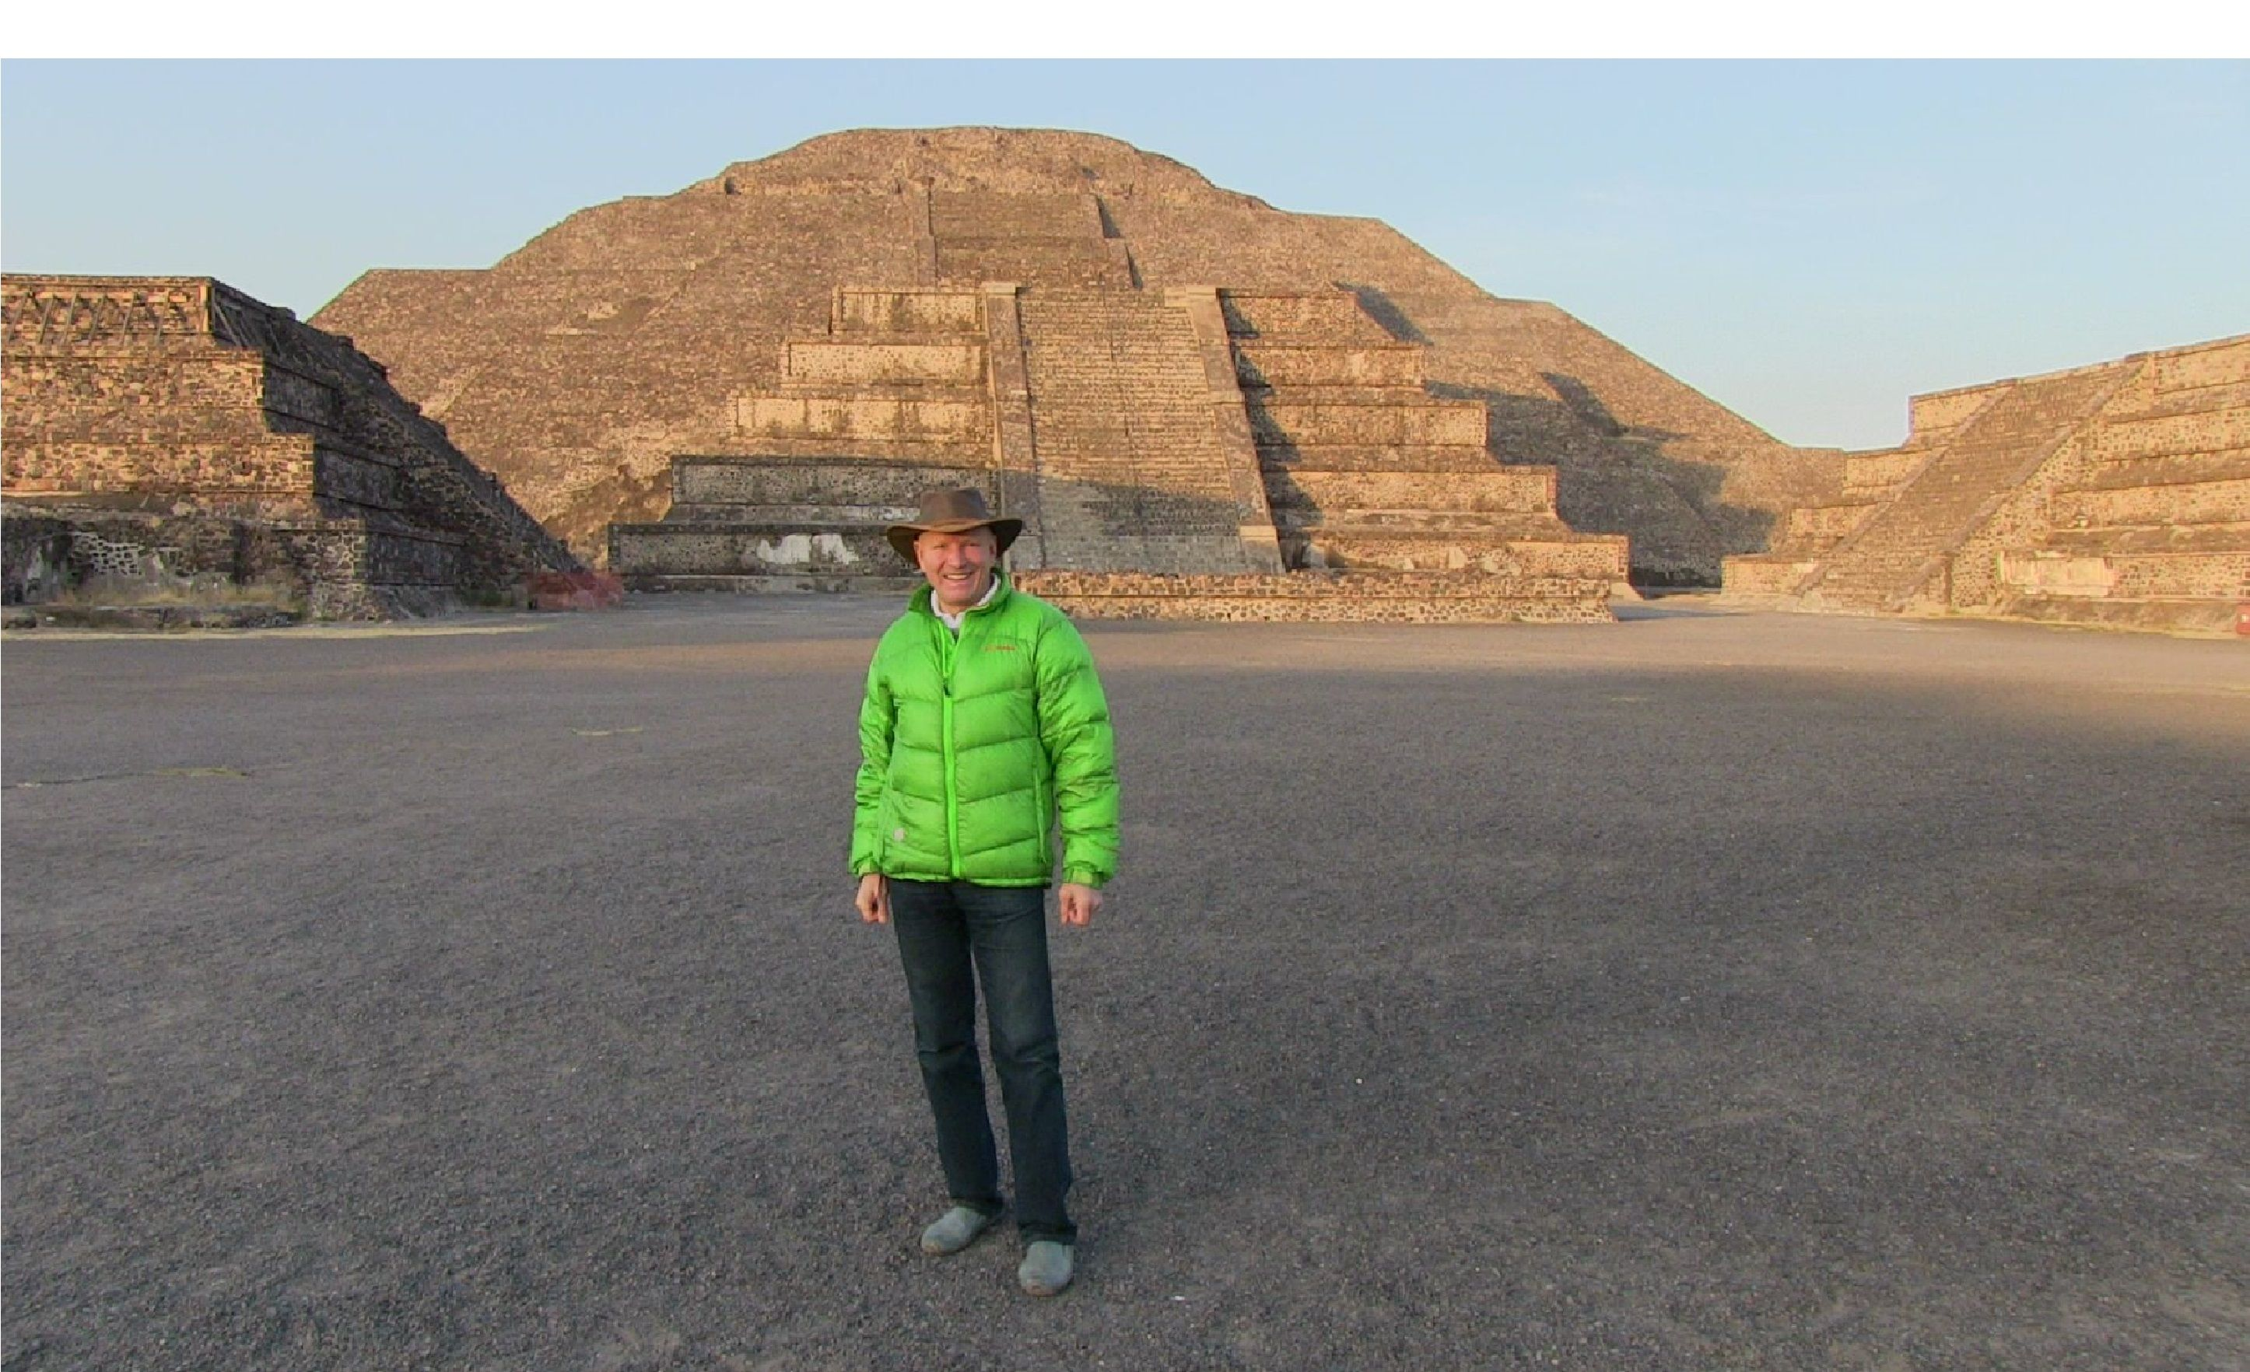

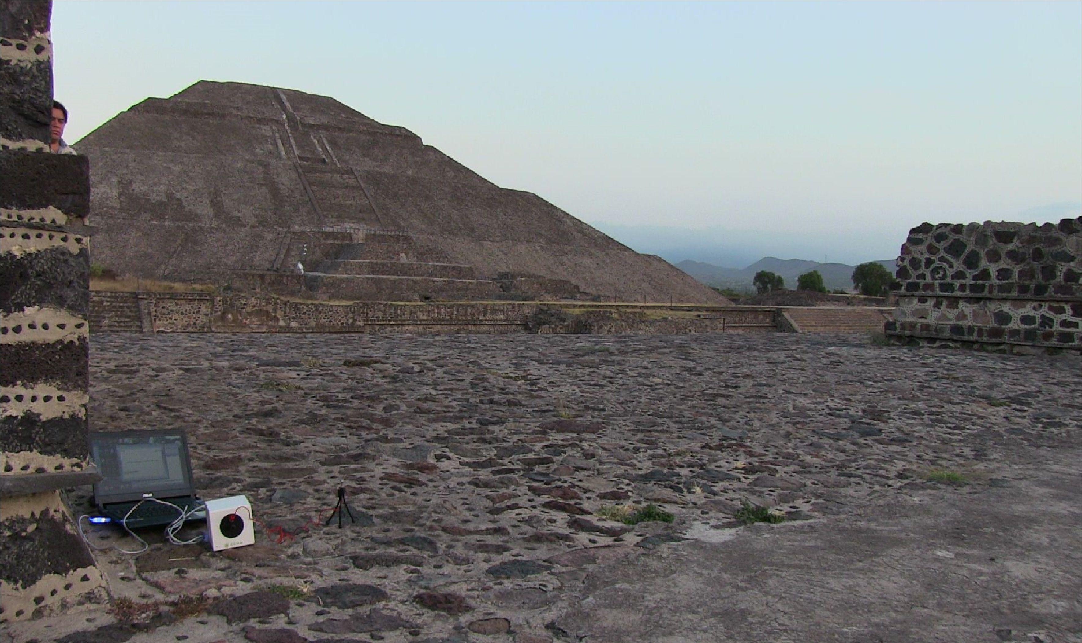

Chichen-Itza
Next day we traveled to Chichen-Itza and visited the pyramid complex in the morning December 23 while it was quite a few tourists there. Energy there was lower than around Teotihuacan pyramids – about two Joules. At some moment Don Ruiz performed mental influence to the Sputnik sensor from the distance of 2 and 5 meters. In both cases strong variations of the parameters were detected after the influence (fig.44).

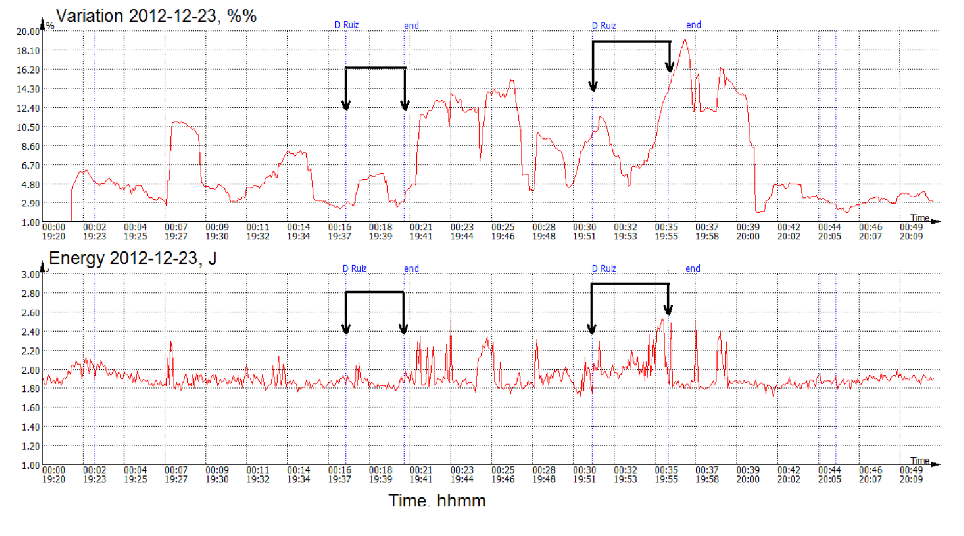
Fig.44. Time dynamics of Energy parameter in the morning December 23 in Chichen-Itza. Moments of Don Ruiz mental influence are marked with arrows

It is interesting that strongest response was noted immediately after the influence.
In the afternoon Don Ruiz had a presentation for a group of people. After beginning of his speech Energy Variation had increased significantly (fig.45), while people began collective meditation, Energy Variation dropped down while increasing by the end of meditation.
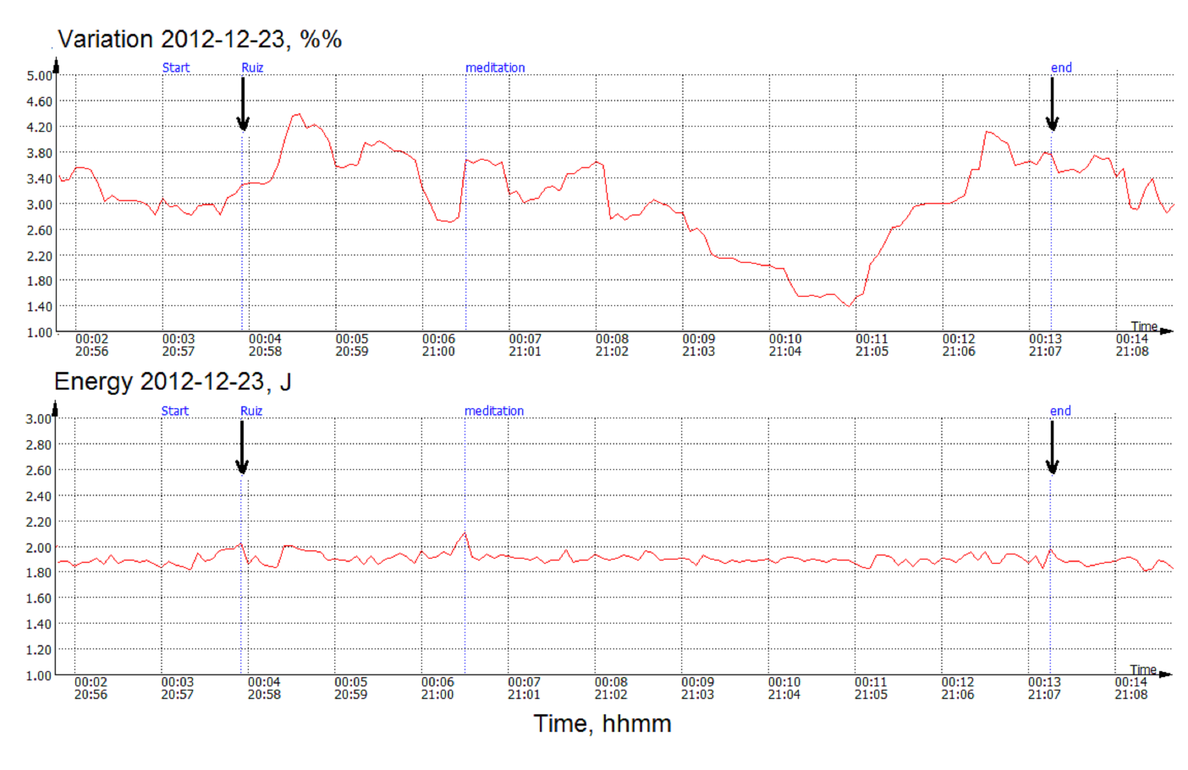
Fig. 45. Time dynamics of Energy during collective meditation 23.12 in Chichen-Itza

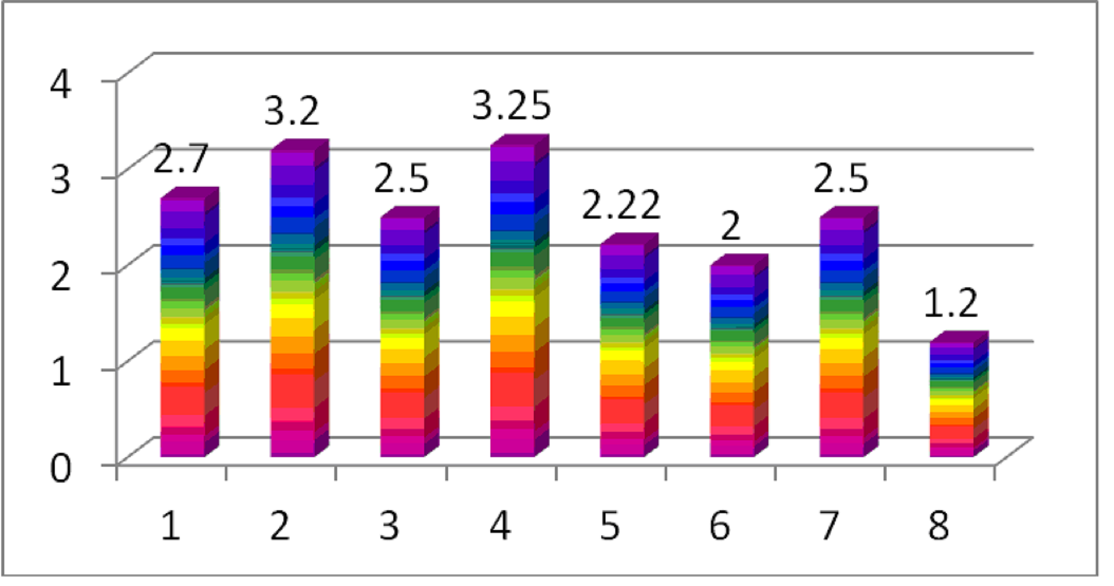
Fig.46. Energy parameter measured at different locations: 1 - at the hotel 20.12.12; 2 - Moon pyramid 20.12.12; 3 - at the hotel 21.12.12 morning; 5 - at the hotel 21.12.12 afternoon; 6 - Chichen-Itza pyramid 23.12.12; 7 - Chichen-Itza influence 23.12.12; 8 - Cancun 24.12.12 morning

It is interesting to compare the level of energy in different places (fig.46). As we see the highest energy level was recorded nearby Teotihuacan pyramids with meditating groups of people. At Chichen-Itza energy was lower, but again – we had increased energy during mediation. And the lowest energy was in Cancun nearby the see (the weather by that moment was excellent and the see was absolutely calm).

Discussion
As we know 21.12.12 at winter solstice Maya predicted the end of a Great Cycle. It is based on the following ideas (http://www.ancient-world-mysteries.com/2012.html):
1) The Maya, as with almost all ancient world cultures, believed that the earth, as part of its natural cycle of being, lives through a series of successive ‘world ages’, each separated by sudden physical planetary upheaval.
2) According to modern day researchers, the Long Count calendar system was established by the Maya in ancient times to forecast or mark out the very transition points between world ages.
3) The primary recurring cycle of the Long Count calendar has been found to consist of precisely 1872000 solar days (approximately equal to 5125.36 years). And this period of time is held to be the very duration of each successive world age.
4) From the study of Long Count inscriptions found at various ancient Mayan settlements, evidence has been uncovered to suggest that the Maya believed the current world age began on 11 August 3114 BC - Gregorian calendar.
5) If the researchers are correct in their reconstruction of the Long Count start-date, which would represent the end of the last world age and the beginning of the present age, then the addition of 1872000 days to the time of 11 August 3114 BC, will place the end of the current age at precisely: 21 December 2012 AD.
At the same time believe that our Earth passes through the Galaxy plane is not true. Astronomers believe the Earth and solar system reside north of the plane of our Milky Way galaxy. It is not known with precision how far north we are of the galactic plane, but estimates place us at a few to several dozen light-years. As the solar system revolves around the center of the Milky Way galaxy in a period of roughly 230 million years, it does bob up and down through the galactic plane in periods of roughly 35 million years. But none of this had any bearing on what was to happen on December 21, 2012.
So – what has happened on 21.12.12?
– Nothing special. At least in Teotihuacan area everything was calm.
– Nothing special, except human emotions. We had expected that a lot of people would have strong emotions by that day. And it was detectable by our instruments. As we see from the data above, we recorded strong variations of Sputnik signal at the moments of collective meditations both 21.12 and 23.12.
These data support an idea developed by many researchers and philosophers for centuries, that Human Consciousness - is an active power of our world!

Don Ruiz Workshop
63 people attended workshop of Don Miguel Ruiz for 5 days with several meditations at the Teotihuacan pyramids. All people were measured with Electrophotonic (GDV) instrument on December 20 after the end of workshop. Results were really amazing !!! all the people had very strong Energy Fields and very low level of stress. Fig 47 presents distribution of stress level for the group. We are evaluation stress level in the scale from 0 to 10. Below 1 is very low level, from 1 to 2 is low, from 2 to 4 is normal level. Above 4 is anxiety and above 7 is stress. As we see from fig.10, for 86% of people the level of stress was from 1 to 2, and all the people had very low level.

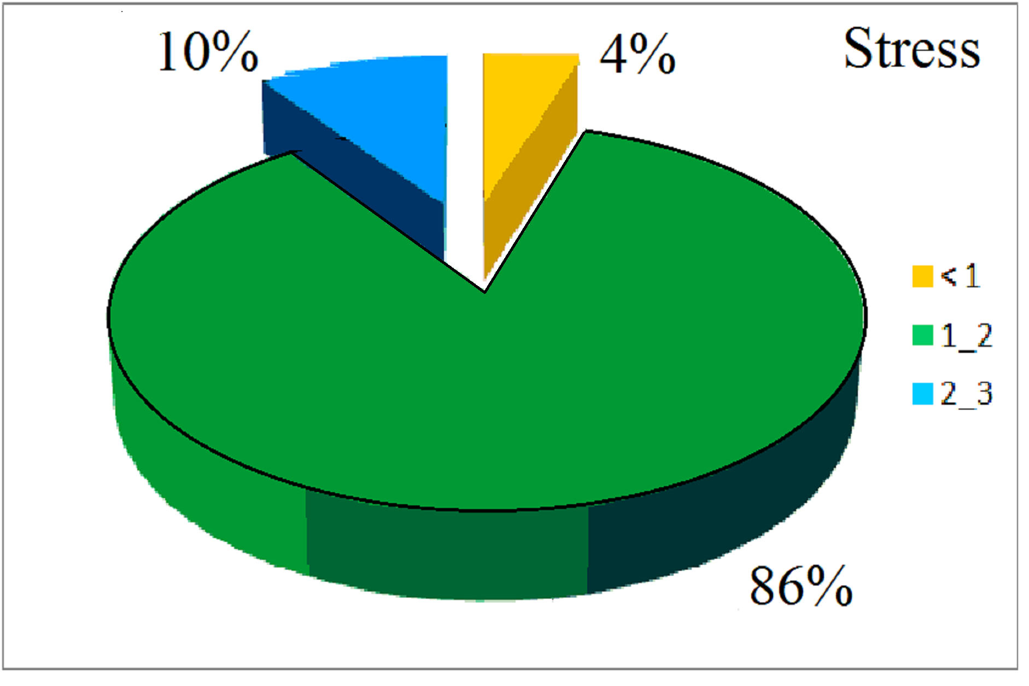
Fig.47. Distribution of Stress level for a group of 63 people
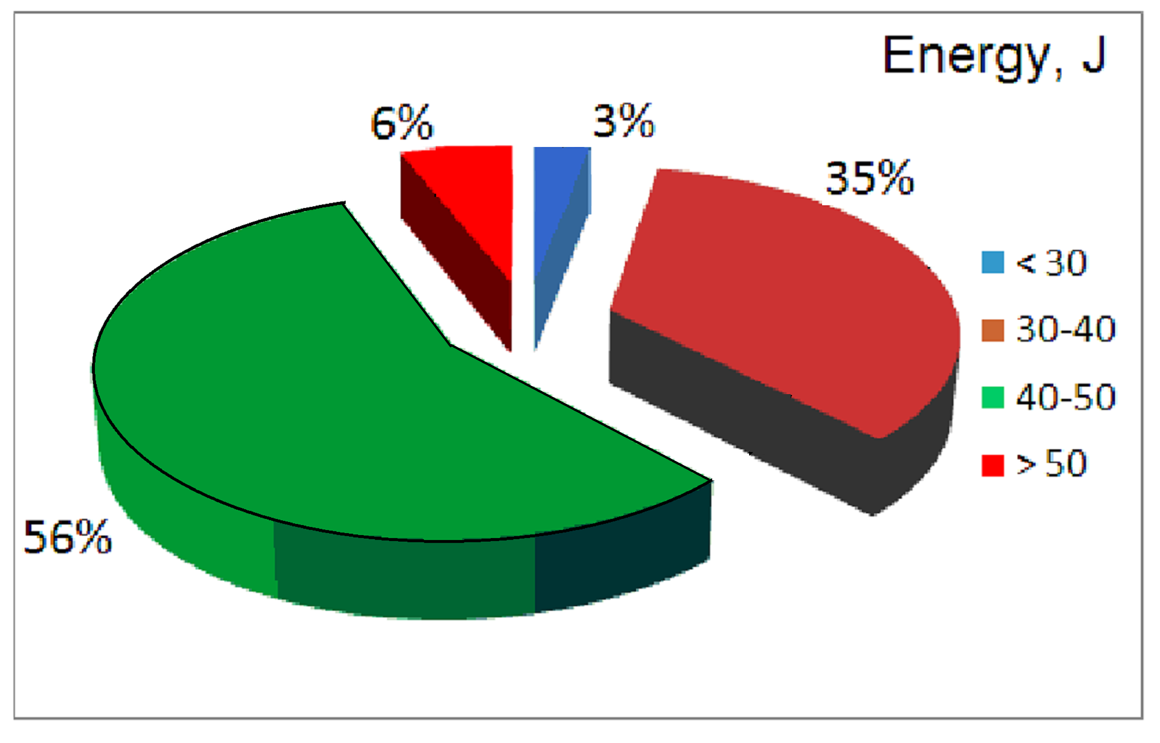
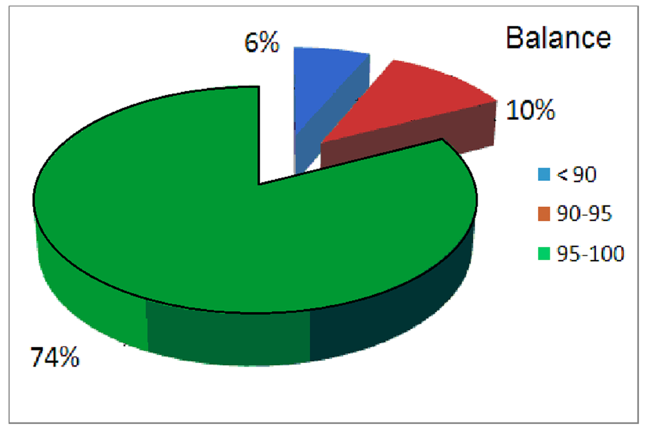
Fig.48. Distribution of Energy parameter and Energy balance parameter for a group of 63 people
Similar data were measured for the Energy parameter. For ordinary people this parameter is usually in the range 30-40 Joules. More than 40 J we recorded for athletes or people in the state of energy agitation. In this group 62% of people had energy more than 40 J, and 6% - more than 50 J (fig.48). This is very unusual result.
Energy balance for most of people was more than 90% that characterize them as very balanced people (fig.48). Distribution of Chakras for all the people were well centered and uniform. Please see an example below.

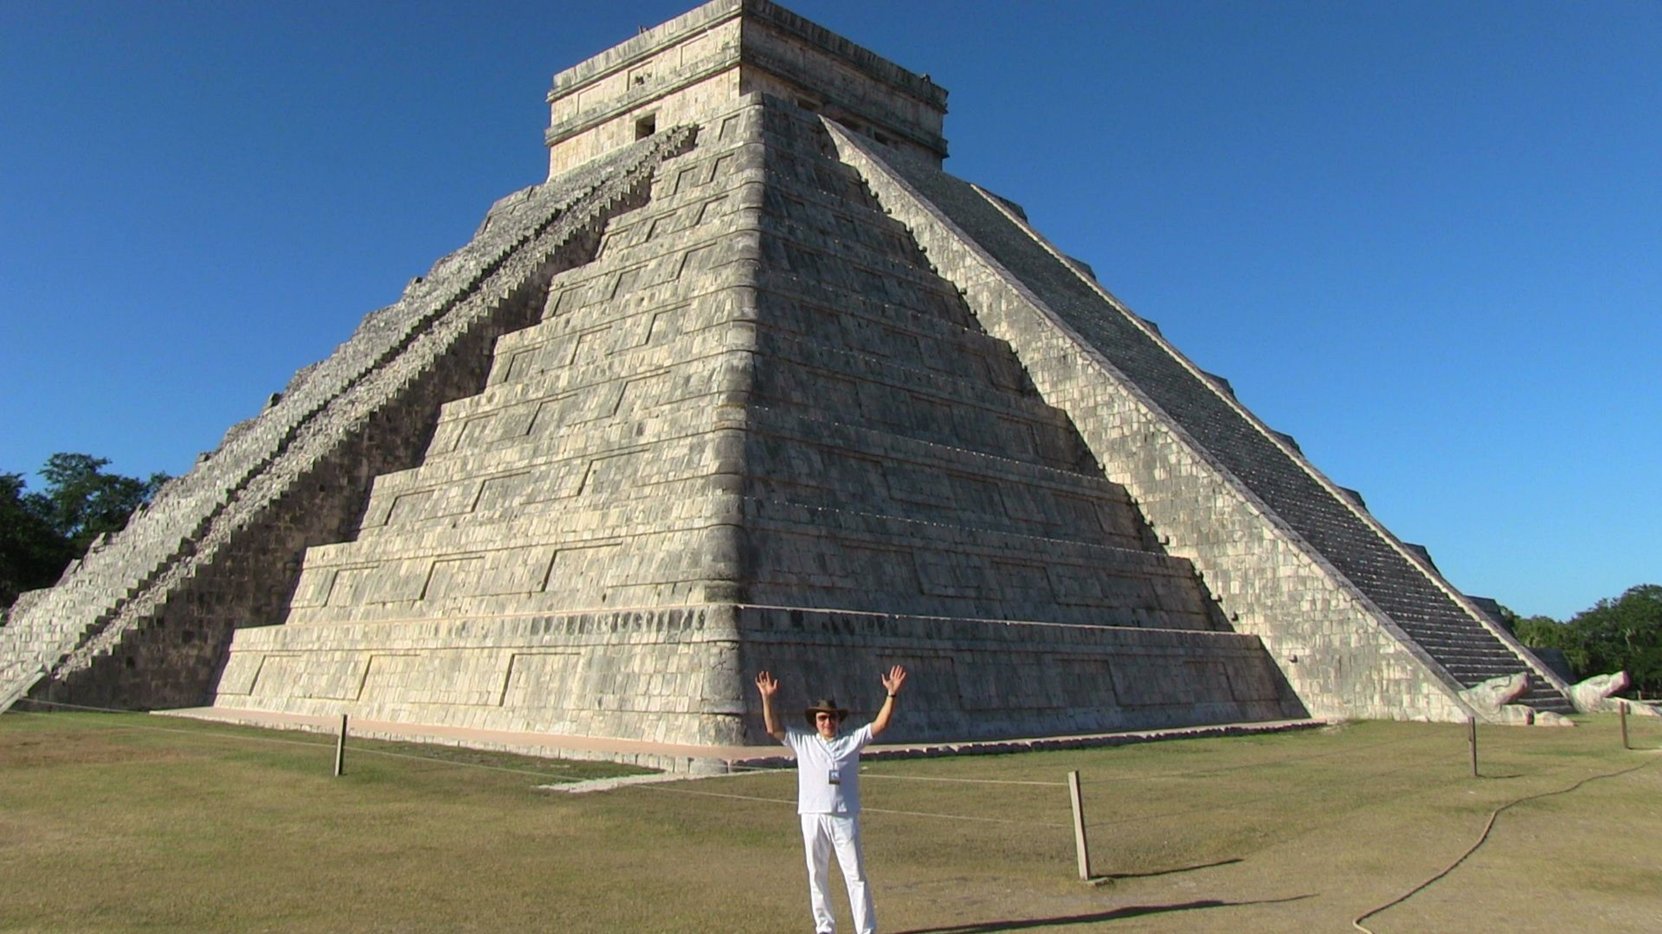

Life is going on!!!! Let us enjoy Life and make the most of it!!!



